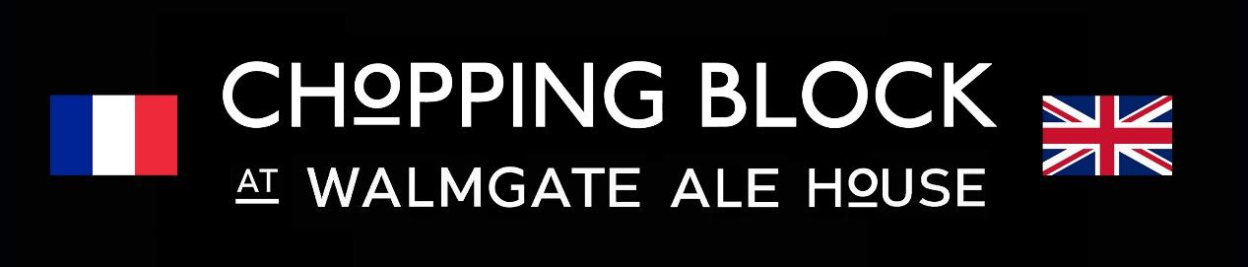

**Christmas Meal Confirmation & Deposit Form**

To make a booking, please provide us with the following information:   
- Booking Name / Organisation  
- Organisers Name (if different from above)  
- Contact Tel No  
- Email address  
- Date of Party  
- Time of Arrival  
- Number in Party

Reserving your table  
This menu is designed for larger, prebooked parties. If you are a smaller party and wish to dine off this menu during the festive period, then please make us aware in your reservation notes.

Opening Days  
Our regular hours are Wednesday from 5pm, and Thursday to Sunday from 12pm. We can open at other times for parties with a minimum food bill spend of £400.  
  
Deposits – 2nd - 15th December

We will require a ***deposit of £10 per head*** for any parties of 15 or more booked on or between these dates***.*** Please contact us on 01904 629222 to pay this over the phone or pay us a visit. Final numbers & deposits are required two weeks prior to the date of your booking. We reserve the right to retain deposits if your numbers do change after this date.   
  
Timings  
Parties arriving before 5pm will have the space reserved for 3 hours; parties arriving after 5pm will be reserved for 4 hours. Please be aware that some of our seating is accessed via our stairs. If you require any alternative arrangements, please let us know.

Pre-order

We do not insist on any party pre-ordering, as our servers are trained in serving larger groups efficiently. However, we do understand that some groups feel more comfortable ordering their food in advance.

If you choose to order in advance, we ask it is in the following format and sent to us electronically. We particularly ask for names of diners next to dishes to avoid any confusion on the day, and a total of each dish.

| Name | Mushrooms | Tartflette | Gratin | Sea Trout | Turkey | Cauliflower | Brandade | Duck | Mousse | Xmas Pud | Sticky | Ice Cream | Cheese | Additional Info |
| --- | --- | --- | --- | --- | --- | --- | --- | --- | --- | --- | --- | --- | --- | --- |
|  |  |  |  |  |  |  |  |  |  |  |  |  |  |  |
|  |  |  |  |  |  |  |  |  |  |  |  |  |  |  |
|  |  |  |  |  |  |  |  |  |  |  |  |  |  |  |
| **Totals** |  |  |  |  |  |  |  |  |  |  |  |  |  |  |

Please make any allergens/dietary requirements very clear & if in any doubt, give us a call & we can help you.

Please see menu on next page.



**CHRISTMAS MENU - £35**  
INCLUDES CRACKERS AND BREAD   
(available all throughout December and by request, in early January)

**STARTERS**

**(v) Pissaladiere**

Onion tart with goats cheese

**Tartiflette**

Baked Cheese over Potatoes , Onions and Bacon

**Boudin Noir**

French style black pudding with cider jus, lardons and apple

**Colin a la Bordelaise**

A baby French fish pie made with cod

**MAINS**

**Hand rolled turkey with sage and onion stuffing**

with roast potatoes & seasonal Vegetables

**Boeuf Bourguignon**

beef braised in red wine, garnished with pearl onions and mushrooms

**(V)Spiced Cauliflower Florets**

coated in Herbs & Breadcrumbs with Red Pepper Ketchup

**Bouillabaisse**

Our take on the traditional Provençal fish dish from Marseille

**DESSERTS**

(V) **Chocolate Mousse** with Orange & Cointreau Cream

(V) **Christmas Pudding** with Brandy Custard

(V)**Sticky Toffee Pudding** with Vanilla Ice Cream

(V) A Selection of **Yorvale Ice-Cream**

(V) **Cheese Board** with Crackers & Celery (£3 supplement)